Seattle to NYC

**WED**15**AUG**

[SEA**11:15 PM**](javascript:void(0))

to

[LGA**09:11 AMARRIVES NEXT DAY**](javascript:void(0))

**Flight Number**

[**DL 354**](javascript:void(0))**Red eye icon,**

**Flight Number**

[**DL 1848**](javascript:void(0))

TRAVEL TIME6h 56m  1 STOP

Basic Economy (E) |  
Basic Economy (E)

[**Nonchangeable/ Nonrefundable**](javascript:void(0))

[**Delta Air Lines Baggage Information**](https://www.delta.com/content/www/en_US/traveling-with-us/baggage/before-your-trip/checked.html)

I chose this flight specifically because it is provided by one of the most trusted airlines companies while also being relatively cheap compared to the others. The day aug/15 has great prices for air-plane tickets as well.

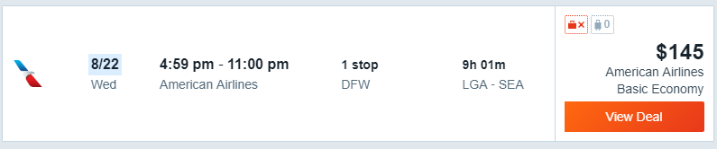

American airlines offers one of the lowest prices for the return ticket on 8/22. I chose this ticket because the timing of it is comfortable. Since it’s 4:59-11:00, the one who is taking the plane ride would not feel mistreated as they don’t want to spend their whole night on an airplane.